 **New Life Christian Academy**

**MATH - Grade 3rd - Teacher Capellán**

**Weekly Lesson Plan (*Plan de Lección- Week from 4th to 8th - May 2020*)**

**Contents (Contenidos) - Chapter 18: Divide by 1 Digit Divisors -**

**Practice Week - Review Concepts**

**MONDAY 4th** 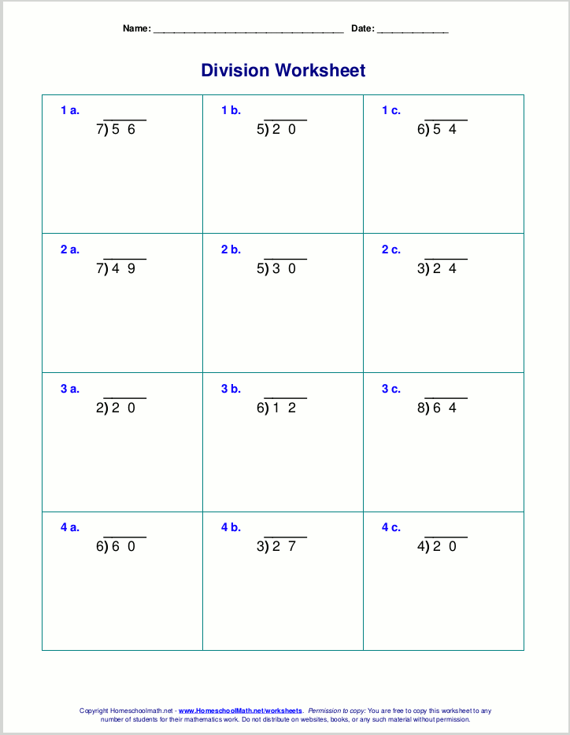

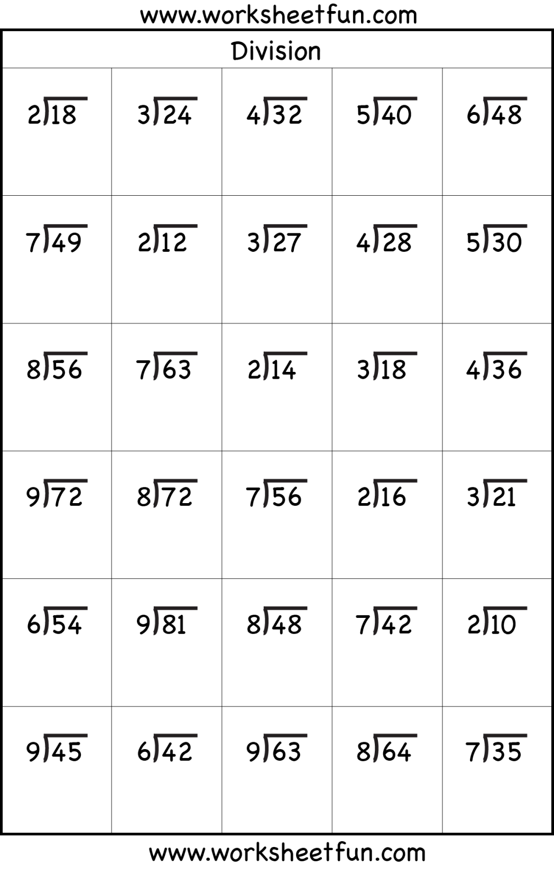

**TUESDAY 5th**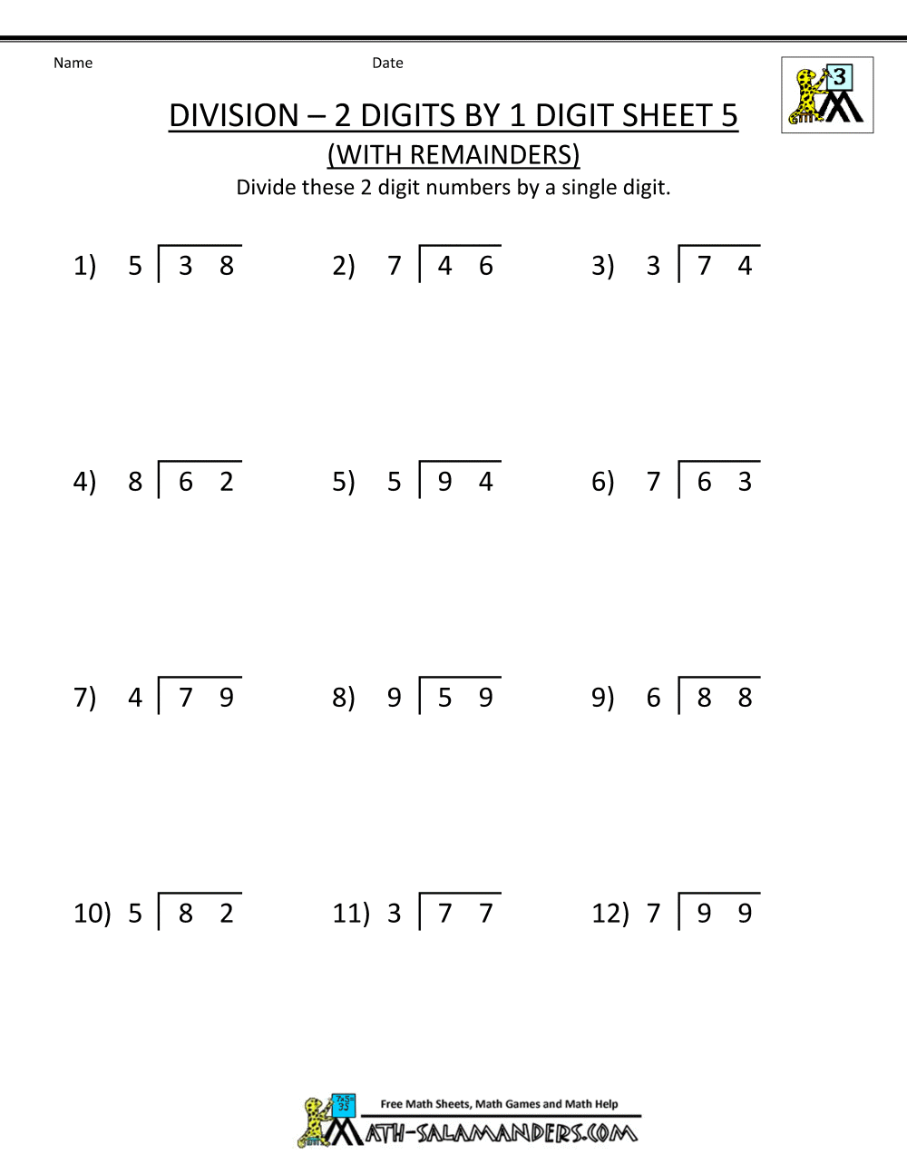

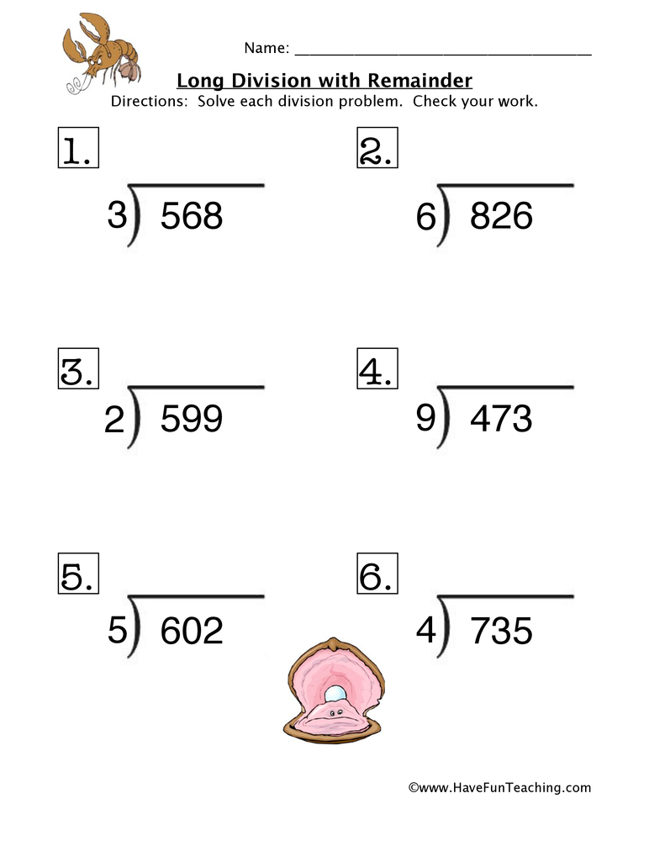

**WEDNESDAY 6th**

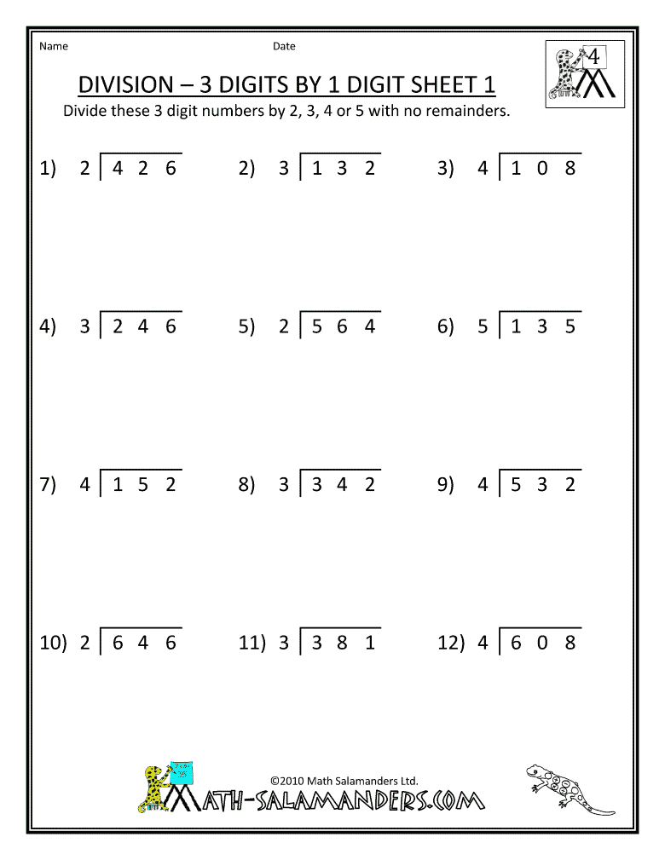

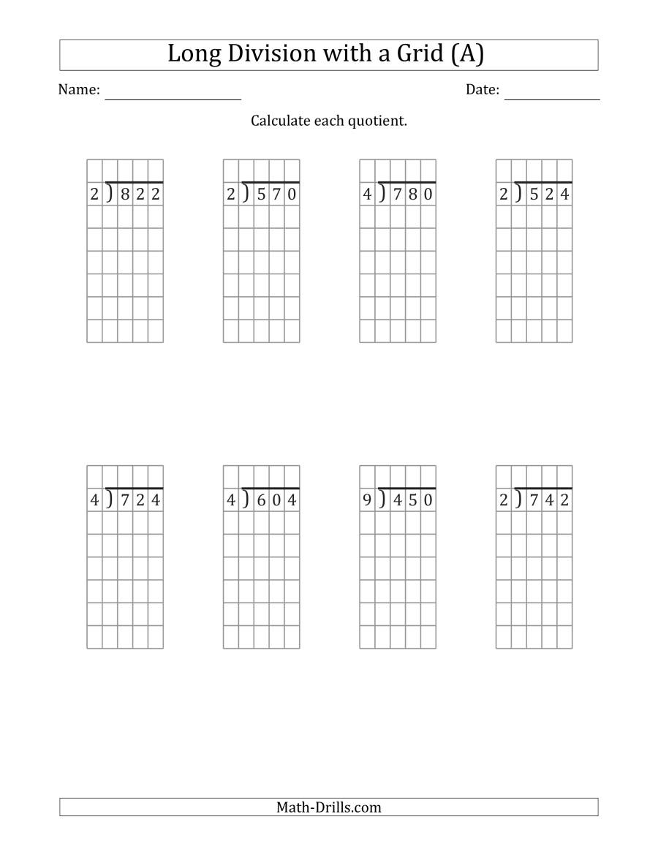

**THURSDAY 7th**

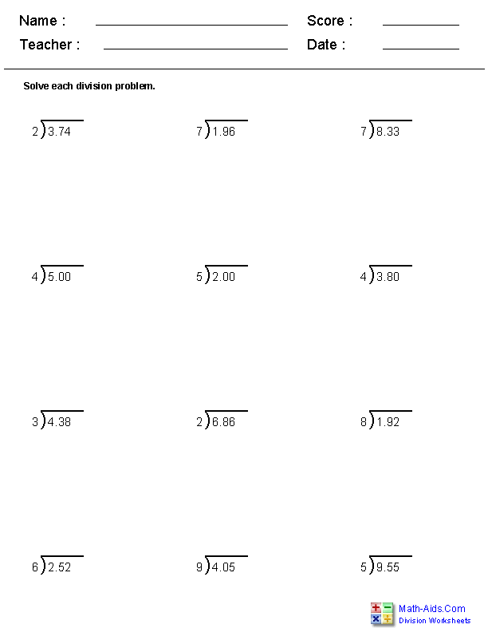

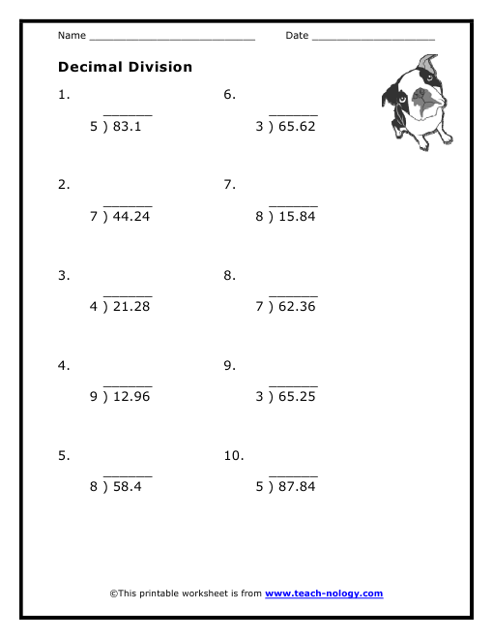

**FRIDAY 8th**

