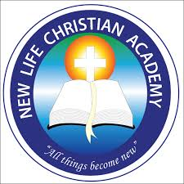

New Life Christian Academy
Replenishment Classes k4 and k5
Math

Pages from 200 to 218.

Work 2 pages per school day.

School days: Tuesday, Wednesday and Friday

